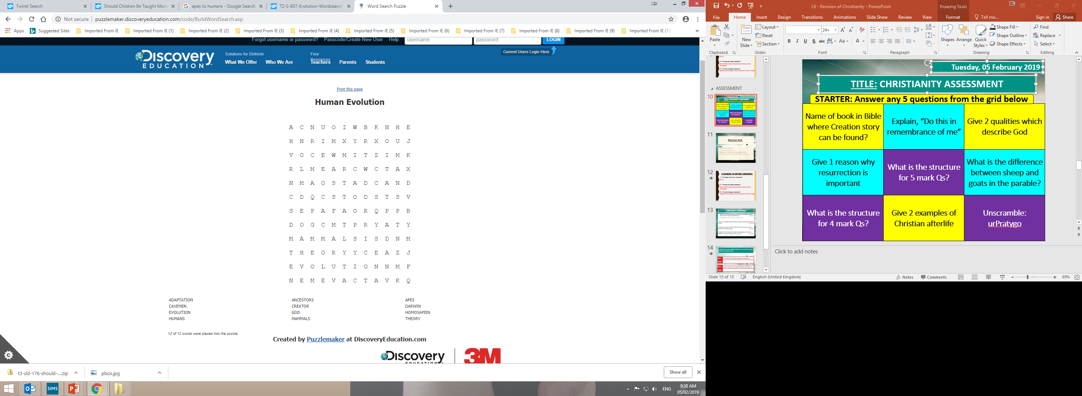
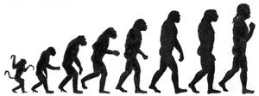
adaptation ancestors apes
cavemen creator Darwin
evolution god homosapien
humans mammals theory
adaptation ancestors apes
cavemen creator Darwin
evolution god homosapien
humans mammals theory

