EXAMPLE 1
Donating clothes/food to refugees fleeing the Taliban in Afghanistan

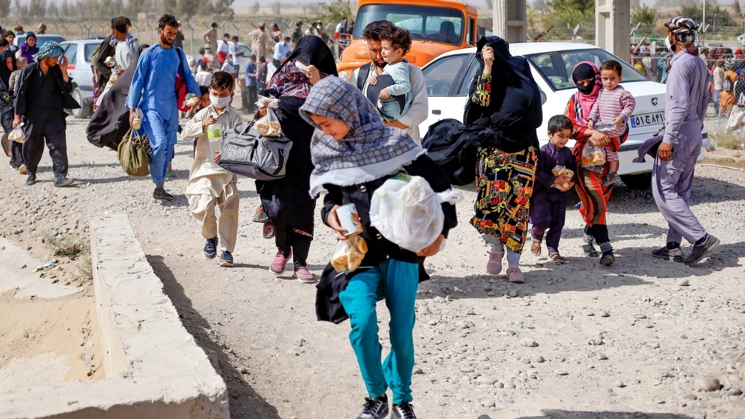

EXAMPLE 2

Singer Adele gifts former English teacher a free ticket to her concert and publicly thanks teacher
EXAMPLE 3
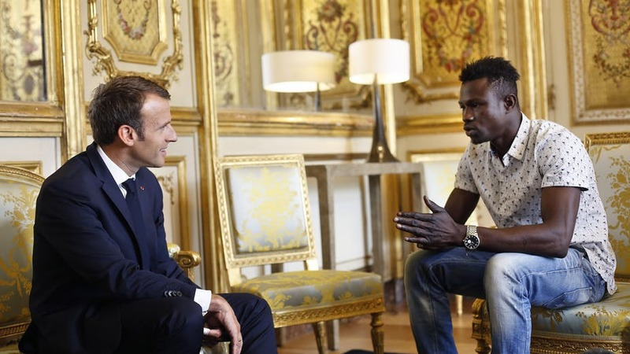
Man risks his own life by saving a falling toddler from balcony
EXAMPLE 4
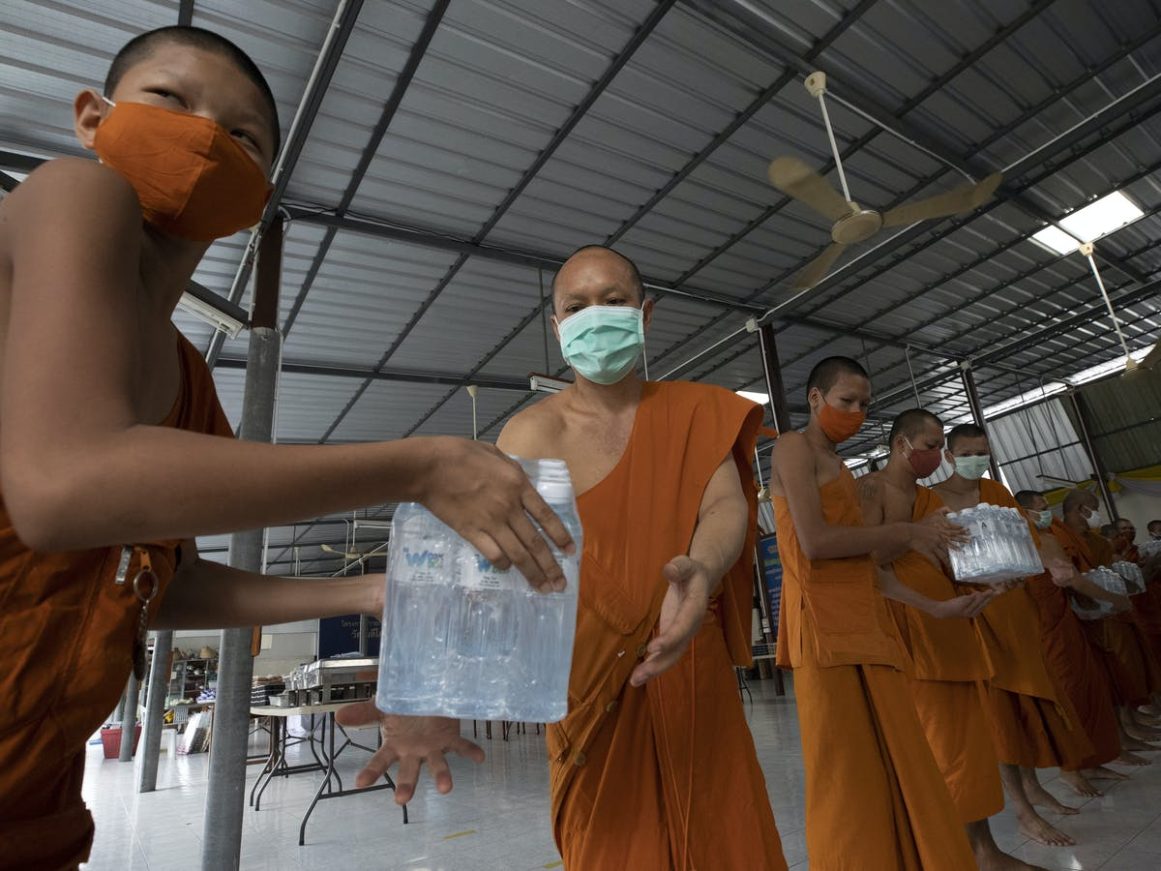
Buddhist Monks take on new jobs to help fight Covid-19
EXAMPLE 5

Public applauds NHS and frontline workers to thank them for their efforts during lockdown
EXAMPLE 6
Buddhist monks open tiger sanctuary to care for tigers left to die in the wild



