
Metta & Karuna

definition
A bad action
8 rules Buddhists follow to achieve enlightenment and reduce suffering
Showing compassion for those who are suffering
A good action
Showing kindness to someone before they need help and not expecting anything back
Actions have positive or negative consequence
Task 1: match your definitions to your keywords
KEYWORD
Metta
Unskilful action
Karuna
Eightfold Path
Karma
Skilful action

Task 3 : Fill in the Eightfold path boxes with skilful actions which show metta or karuna
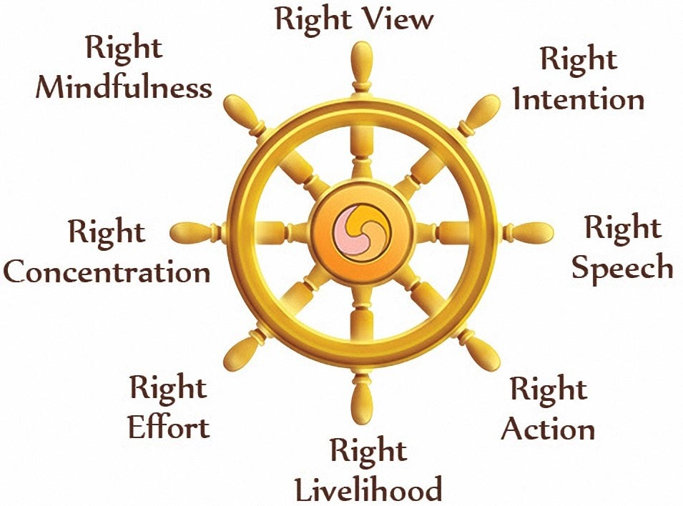

Examples of metta and karuna
Task 2 : Fill in the Eightfold path boxes with skilful actions which show metta or karuna

Example | Metta  (kindness before suffering occurs) | Karuna  (compassion to help suffering)
E.G. Marcus Rashford wins his campaign for pupils to continue to receive free school meals during lockdown |  | 
e.g. 1 Donating clothes or…
e.g. 2 Singer Adele…
e.g. 3
e.g. 4
e.g. 5 Public applauds NHS and…
e.g. 6
GLUE ALONG HERE
GLUE ALONG HERE

