WHO WAS CHARLES DARWIN?  - Charles Darwin was born on 12th February 1809 in Shrewsbury, England.  - Darwin was made to train to be a Christian priest by his father but Darwin wasn’t interested in religion!  - Darwin later went on to become famous for his Theory of Evolution that talked about apes evolving into humans over millions of years.  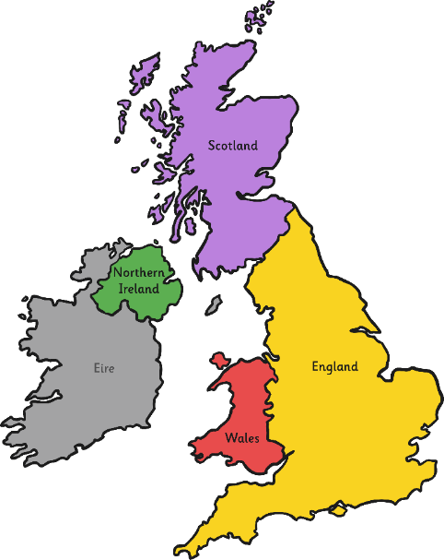  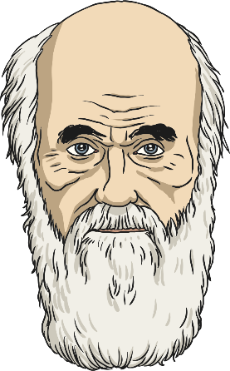  Shrewsbury | ANGER AT CHARLES!  - Religious leaders from Churches were disgusted with Darwin’s claim that humans evolved from apes. Only God could be responsible for creation, they believed.  - The public laughed at Darwin’s scientific findings and rejected them as the UK was a largely Christian country.  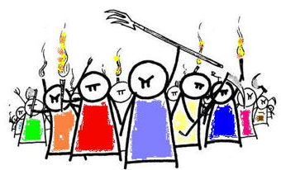  - It wasn’t until 1900’s that Darwin’s theory of evolution was accepted as scientific proof of the evolution of humans through apes.

THE BEAGLE  - Darwin was given an opportunity to be a paid explorer. As an explorer, Darwin had to collect information about rocks, animals and plants.  - Darwin had to board a ship called The Beagle to get to the Galapagos Islands, where he would start his dream job as an explorer.  - Living conditions on the ship were awful with dust everywhere. Darwin was often seasick and caught a fever.   | THE ORIGIN OF SPECIES  - Darwin wrote a famous book called, The Origin of Species.  - He wrote about the things he found on his travels around the world and how plants and animals evolved over time.    - The changes in evolution led him to believe that humans developed over time from apes.  The Origin of Species

GALAPAGOS ISLANDS  - Darwin found plants and animals that nobody had ever seen before on the Galapagos Islands!  - Darwin studied birds called Finches in Galapagos, he realised even though they were different, they all had similarities and had changed through evolving and adapting to their environment!  - Darwin took seeds from Galapagos to take home with him. He found that celery and rhubarb grew well in the U.K  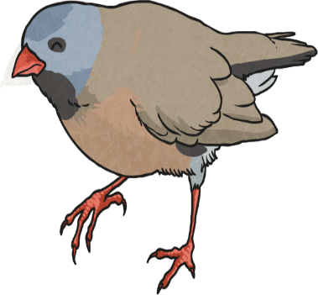  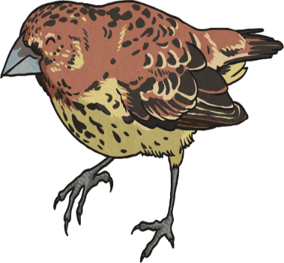  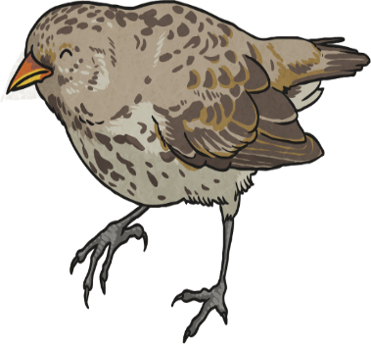 | HUMAN EVOLUTION  - Darwin discovered that over millions of years humans developed from apes as they shared the same ancestors.  - Earlier humans evolved to make adaptations to not only survive but to survive better. Some of these changes are down to habitats.  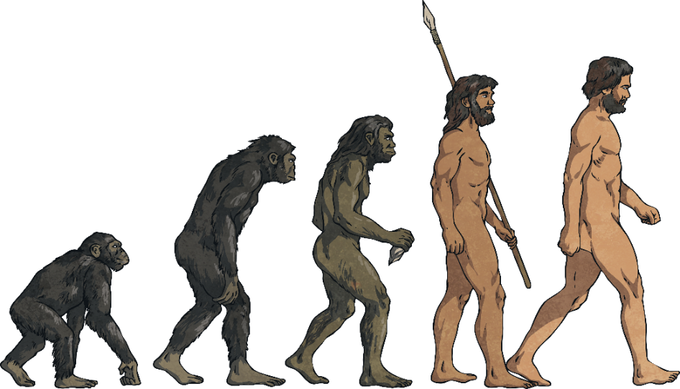  - Humans evolved from apes and cavemen, we are no longer hairy like them because we have adapted to our current environment and we don’t live in the Ice Age anymore.

